How the Churches Log into ABC Cooperating Church Annual Report in NetSuite
Step 1
You will receive an email from the Region.
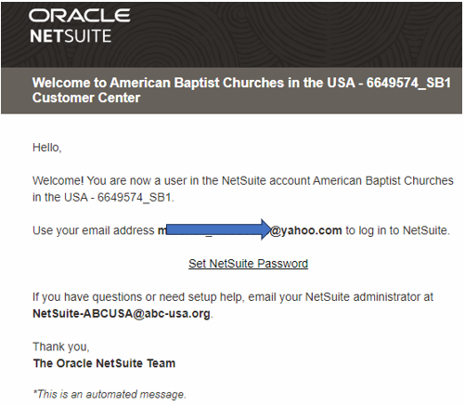
Step 2
Click on Set NetSuite Password.
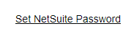
Step 3
It will take you to this page and the church will update the password.
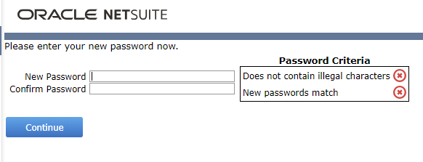
Step 4. It will take you to this page and state the password has been set up.
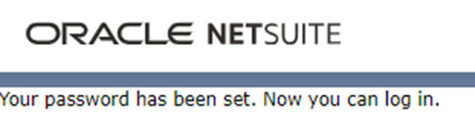

Step 5. After resetting the password, the church will receive an email. It will confirm that the password is set.
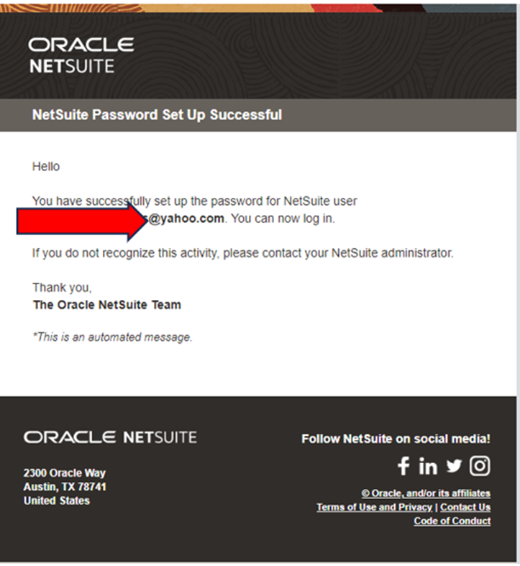

Step 6. After updating the password. The church will utilize this link to log into NetSuite: https://6649574.app.netsuite.com/app/login/secure/privatelogin.nl?c=6649574
THIS IS VERY IMPORTANT FOR THE CHURCH TO HAVE THIS LINK. After logging into NetSuite with the username and password, they will see a home dashboard below: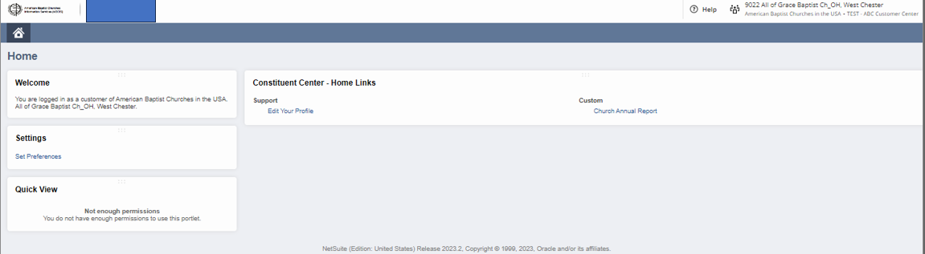

Step 7
Click on Church Annual Report
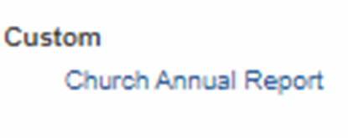
Step 8
Click on New ABC Cooperating Church Annual Report
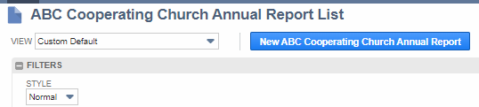
Step 9
Make sure the Annual Year and Constituent are correct. It should show the current year, for example 2023 and the Constituent should be your church.
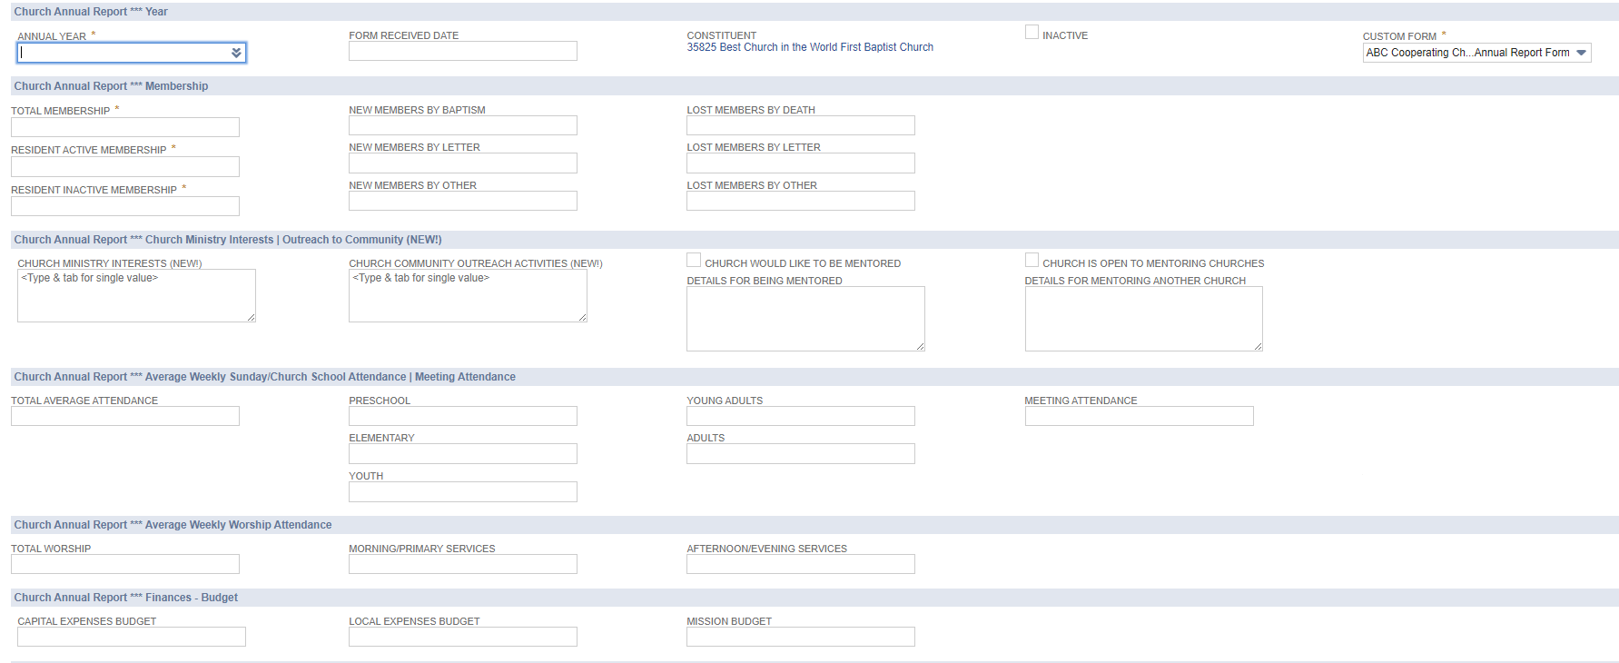
Step 8
Update the information on the page and click on SAVE afterwards.
Step 9
Contact your region and state it was completed in the system.

